HIGHLEY PARISH COUNCIL
Clerk: Mrs E Preston
81 Woodhill Road, Highley, Bridgnorth, Shropshire, WV16 6HU
Telephone: 01746 861979
Email: clerk@highleyparish.couk

Date: 23rd February 2021
To: All Parish Council members
The Public and Press

You are summoned to attend an ordinary Meeting of Highley Parish Council which will be held via video link (Zoom) Tuesday 2nd March 2021 at 7pm for the transaction of business as set out in the agenda below.

Members of the public are invited to address the Council at the start of the meeting.

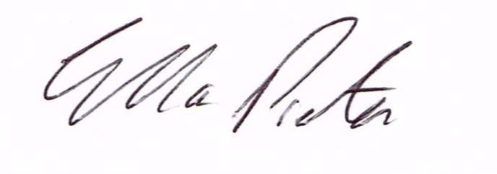
ELLA PRESTON
CLERK TO HIGHLEY PARISH COUNCIL.

AGENDA:

- Parishioners Time (15 minutes) - Speaking at a Meeting - You do not have the right to speak at a meeting unless invited to do so by the Council. If you wish to speak /attend, then you must contact the Clerk beforehand so that a link to the meeting can be emailed to you.

Declaration of any disclosable pecuniary interest in a matter to be discussed at the meeting. Members are reminded that they are required to leave the room during the discussion and voting on matters in which they have a disclosable pecuniary interest, whether the interest is entered in the register of member’s interest maintained by the monitoring officer.

01 Apologies for absence and reasons for absence

02 To confirm the minutes of the meetings dated 2nd February 2021

03. Matters Arising
CCTV – Update
Youth Project – Update from Cllr.Vinall.
Medical Issues – Any update from Councillors
Waiting Restrictions High Street – Update from Shropshire Council sent to all Councillors – Still going through the process at Shropshire Council

04.Correspondence (All correspondence emailed to Councillors – if you wish anything discussed please contact the Clerk).
SALC – News in Brief - Contact Information, Lockdown Summary
Revd. M.Harris – School Governor Vacancy Information
Road Closure: Halfway House Lane, Eardington, Bridgnorth
SALC – Community Reassurance Team Update
SALC – Criminal Exploitation of Children
Shropshire Council Elections Office – Nomination Papers
SALC - Community Governance Reviews
05. Planning

Reference: 21/00749/TPO (validated: 15/02/2021)
Address: 17 Hawthorn Drive, Woodhill, Highley, Bridgnorth, Shropshire, WV16 6DF
Proposal: Works to reduce crown of 1No Oak Tree by approx. 1.5-1.8m protected by The Bridgnorth District Council (Hazelwells, Highley) TPO 1978
Applicant: Mr Pete Turner

06. Email System – from December 2020 Meeting

07. Churchyard Maintenance – Tenders for Maintenance and any further information received regarding financial assistance . (Details emailed to all Councillors)

08. Severn Centre Advisory Board Meeting –Minutes from the meeting sent to all Councillors.

09. Youth Project – Cllr.Vinall – Emailed to all Councillors

10. Netherton Lane – Cllr.Thakrar

11. Shropshire Councillors Report. Attached.

12 Finance: Clerks Salary - HMRC – Tax and National Insurance. , S.J.Maintenance – Village Maintenance issues. Hi line Electrical – Christmas Lights . Plus, any other invoices received prior to meeting

