HIGHLEY PARISH COUNCIL
Clerk: Mrs E Preston
81 Woodhill Road, Highley, Bridgnorth, Shropshire, WV16 6HU
Telephone: 01746 861979
Email: clerk@highleyparish.couk

Date: 28th June 2021
To: All Parish Council members
The Public and Press

You are summoned to attend an ordinary Meeting of Highley Parish Council which will be held at the Severn Centre Highley on Tuesday 6th July 2021 at 7pm for the transaction of business as set out in the agenda below.

Members of the public are invited to address the Council at the start of the meeting .Due to Covid Restrictions please contact the Clerk prior to the meeting to book a space.

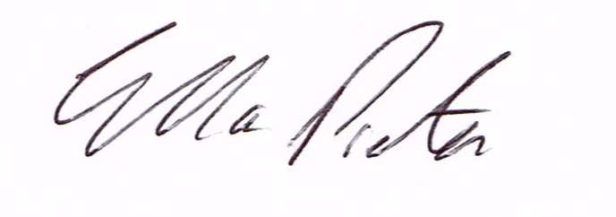
ELLA PRESTON
CLERK TO HIGHLEY PARISH COUNCIL.

AGENDA:

00. Parishioners Time (15 minutes) - Speaking at a Meeting - You do not have the right to speak at a meeting unless invited to do so by the Council. If you wish to speak /attend, then you must contact the Clerk beforehand so that a link to the meeting can be emailed to you.

Declaration of any disclosable pecuniary interest in a matter to be discussed at the meeting. Members are reminded that they are required to leave the room during the discussion and voting on matters in which they have a disclosable pecuniary interest, whether or not the interest is entered in the register of member’s interest maintained by the monitoring officer.

01 Apologies for absence and reasons for absence

03 To confirm the minutes of the meetings dated 8th June 2021 and Extraordinary Meeting dated 28th June 2021

04. Matters Arising
CCTV – Update
Youth Project – Update from Cllr.Vinall.
Litter – Cllr. A.Rodgers
Communications Working Group – Report from Meeting
Housing Needs Survey Results
New Email System – 12th August 2021

05.Correspondence (All correspondence emailed to Councillors – if you wish anything discussed please contact the Clerk).
SALC - Community diagnostics hubs - have your say
PCSO J.Fletcher- Parish Charter
Road Closure: Church Lane, Highley. Start Date: 16th August 2021. End Date: 20th August 2021.
Purpose: Road Closure: Cadent - New gas connection
Bridgnorth Area Committee SALC – Notes from meeting
SALC –
Safety Alert -sharps and positioning (Info Only)
SALC – The Queens Platinum Jubilee Beacons – 2nd June 2022
SALC – News in Brief
Road Closure: Ingram Lane, Chelmarsh - Start Date: 15th July 2021 - End Date: 23rd July 2021Purpose: Road Closure to enable Multievo carriageway repair.
Road Closure: New Road Highley- - Start Date: 12th July 2021 - End Date: 14th July 2021 - Purpose: Road Closure to complete Multievo Highways works

06. Planning

Can you please ensure that you look at these plans on Shropshire Councils planning portal prior to the meeting as we do not receive hard copies of the plans

Reference: 21/03055/TPO (validated: 18/06/2021)
Address: Adjacent St Peters View, Highley, Bridgnorth, Shropshire, WV16 6LB
Proposal: Crown lift by up to 2.5 metres & selective branch reduction of approx. 1-3metres of 4no Lime protected by the Shropshire Council (South of Vicarage Lane and west of St Peter's View, Highley) TPO 2019 (Ref: SC/00445/19)
Applicant: STAR Housing (The Spruce Building, Sitka Drive, Shrewsbury, Shropshire, SY2 6LG)

07. CCTV Monitors – Quotation attached.

08. Christmas Lights – Display 2021

08. CIL – General Discussion

09. Grant Request – Highley Brownies

10.Shropshire Councillors Report

11. Finance: Clerks Salary - HMRC – Tax and National Insurance. , S.J.Maintenance – Village Maintenance issues –Shorthouses Skip Hire, Viking – Stationery ,. Plus, any other invoices received prior to meeting

