HIGHLEY PARISH COUNCIL
Clerk: Mrs E Preston
81 Woodhill Road, Highley, Bridgnorth, Shropshire, WV16 6HU
Telephone: 01746 861979
Email: clerk@highleyparish.couk
27th September 2021
To: All Parish Council members
The Public and Press

You are summoned to attend an ordinary Meeting of Highley Parish Council which will be held at the Severn Centre Highley on Tuesday 7th September 2021 at 7pm for the transaction of business as set out in the agenda below.

Members of the public are invited to address the Council at the start of the meeting .Due to Covid Restrictions please contact the Clerk prior to the meeting to book a space.

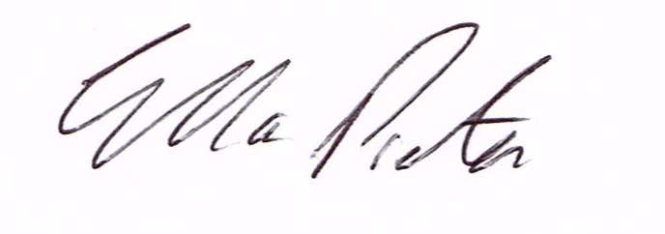
ELLA PRESTON
CLERK TO HIGHLEY PARISH COUNCIL.

AGENDA:

00. Parishioners Time (15 minutes) - Speaking at a Meeting - You do not have the right to speak at a meeting unless invited to do so by the Council. If you wish to speak /attend, then you must contact the Clerk beforehand so that a link to the meeting can be emailed to you.

Declaration of any disclosable pecuniary interest in a matter to be discussed at the meeting. Members are reminded that they are required to leave the room during the discussion and voting on matters in which they have a disclosable pecuniary interest, whether or not the interest is entered in the register of member’s interest maintained by the monitoring officer.

01 Apologies for absence and reasons for absence

02 To confirm the minutes of the meetings dated 5th September 2021

03 Matters Arising
CCTV – Update
Youth - Update
Communication Working Group – Report from meeting
Deputy Police and Crime Commissioner – Report from Visit
Bridgnorth and Shifnal Area Committee Meeting – Report sent to all Councillors

04.Correspondence (All correspondence emailed to Councillors – if you wish anything discussed please contact the Clerk).
SALC – New in Brief
Shropshire Council – Review of planning committees – survey
SALC – submission of local plan – 3rd September
Severn Centre Board Meeting 13th October

05. Planning
Reference: 21/04311/LBC (validated: 24/09/2021)
Address: Manor House , Main Road, Highley, WV16 6NG
Proposal: Replacement of UPVC windows with traditional timber casements and front door, replacement of insensitive putty/silicone sealing to brick noggin panels externally, where brickwork meets timber framing, repointing to areas requiring attention to external elevations, repainting of external brickwork with a more appropriate paint affecting a Grade II Listed Building
Applicant: Mr Steve Chappell (Manor House, Main Road, Highley, WV16 6NG)

06. Highley parish Council Accounts – External Auditors Report – Emailed to all Councillors

07- Annual Parish Meeting – Civic Award Nominees – from last meeting

08..Revenue and Resources Committee – Report from meeting

09.. Royal British Legion Poppy Appeal – To agree expenditure and Donations – Wreath and Tommy – las year donation was £250

10. Severn Centre Annual Contract Review – Attached.

11. Severn Valley Country Park – Grant (£400 already Resolved to pay)

13. Highley Youth project – Grant (Contract already signed and agreed)

13. Terms of Reference Cllrs. T.Quinn and A.Rodgers – see attached.

14.Shropshire Councillors Report

15 Finance: Clerks Salary - HMRC – Tax and National Insurance. , S.J.Maintenance – Village Maintenance issues – Severn Centre Room Hire, Plus, any other invoices received prior to meeting

