HIGHLEY PARISH COUNCIL
Clerk: Mrs E Preston
81 Woodhill Road, Highley, Bridgnorth, Shropshire, WV16 6HU
Telephone: 01746 861979
Email: clerk@highleyparish.couk
30th November 2021
To: All Parish Council members
The Public and Press

You are summoned to attend an ordinary Meeting of Highley Parish Council which will be held at the Severn Centre Highley on Wednesday 8th December 2021 at 7pm for the transaction of business as set out in the agenda below.

Members of the public are invited to address the Council at the start of the meeting .Due to Covid Restrictions please contact the Clerk prior to the meeting to book a space.

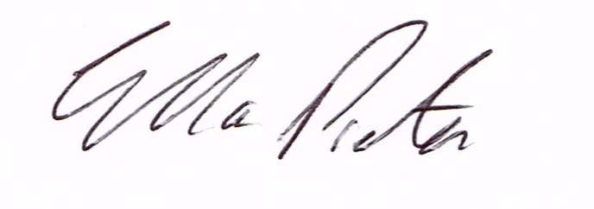
ELLA PRESTON
CLERK TO HIGHLEY PARISH COUNCIL.

AGENDA:

00. Parishioners Time (15 minutes) - Speaking at a Meeting - You do not have the right to speak at a meeting unless invited to do so by the Council. If you wish to speak /attend, then you must contact the Clerk beforehand so that a link to the meeting can be emailed to you.

Declaration of any disclosable pecuniary interest in a matter to be discussed at the meeting. Members are reminded that they are required to leave the room during the discussion and voting on matters in which they have a disclosable pecuniary interest, whether or not the interest is entered in the register of member’s interest maintained by the monitoring officer.

01 Apologies for absence and reasons for absence

02 To confirm the minutes of the meetings dated 5th October 2021

03. Matters Arising
Youth Project – Update from Cllr.Vinall.
Civic Awards and Christmas Light Switch on – Report from meeting
Welcome Back Fund – Update
Castle Inn – Update

04.Correspondence (All correspondence emailed to Councillors – if you wish anything discussed please contact the Clerk).
SALC – New in Brief
Shropshire Public Health – Community Outreach Scheme – at Severn Centre 1st and 3rd December
Cllr. J.Rakic – Resignation from Parish Council.
Shrewsbury and Telford NHS Trust – Cardiology and and Inpatient Services

05. Planning

Reference: 21/05409/VAR (validated: 17/11/2021)
Address: The Stables , Bridgnorth Road, Highley, WV16 6HE. Proposal: Removal of Condition No. 3 attached to planning permission 89/1150 dated Reference: 21/05280/FUL (validated: 11/11/2021)

Reference: 21/05280/FUL (validated: 11/11/2021)
Address: Highfield , New Road, Highley, WV16 6NN. Proposal: Erection of new front porch
reference: 21/04311/LBC (validated: 24/09/2021)

Planning Decision

Reference: 21/04927/CPE (validated: 15/10/2021). Address: Romyra, Annexe , Blything Court, Highley, WV16 6JL ‘ Proposal: Application for Lawful Development Certificate for the existing use of annex as a separate dwelling - Decision: Certificate – Lawful

Reference: 21/02188/FUL (validated: 29/04/2021)
Address: Proposed Caravan Site NW Of Millstone Cottage, Severn Side, Highley, Shropshire
Proposal: Application under Section 73A of the Town and Country Planning Act 1990 for the retrospective change of use of land to accommodate two glamping pods and conversion of (part of) existing dwelling to form one holiday let property. Decision: Grant Permission

Reference: 21/04761/TCA (validated: 02/10/2021)
Address: St Marys Church, Highley, Shropshire, WV16 6NA. Proposal: Fell 1no Sycamore within Highley Conservation Area. Decision: No Objection

Reference: 21/04311/LBC (validated: 24/09/2021)
Address: Manor House , Main Road, Highley, WV16 6NG
Proposal: Replacement of UPVC windows with traditional timber casements and front door, replacement of insensitive putty/silicone sealing to brick noggin panels externally, where brickwork meets timber framing, repointing to areas requiring attention to external elevations, repainting of external brickwork with a more appropriate paint affecting a Grade II Listed Building. Decision: Grant Permission.

06 – Queens Jubilee Celebrations – Cllr. J.Marshall

07. War Graves – Cllr.D.Tremellen - War Graves in St. Marys Churchyard

08. Parish Council Planters- Cllr. Tremellen – To discuss the condition of the planters in the village

09. Climate Change Measures – Cllr. E.Moore – from last meeting

10. Shropshire Councils Report

11,Finance – M.E.Preston – Salary. HMRC Tax & NI. S.J.Maintenance – Maintenance Work. Severn Centre – Room Hire.Sparton Trophies – Civic Awardsi– Plus any other Cheques that come in prior to meeting.

