HIGHLEY PARISH COUNCIL
Clerk: Mrs E Preston
81 Woodhill Road, Highley, Bridgnorth, Shropshire, WV16 6HU
Telephone: 01746 861979
Email: clerk@highleyparish.couk

Date: 28th April 2019
To: All Parish Council members
The Public and Press

You are summoned to attend The Annual Meeting of Highley Parish Council which will be held on Tuesday 7th May 2019 at the SEVERN CENTRE, HIGHLEY at 7pm for the transaction of business as set out in the agenda below.
Members of the public are invited to address the Council at the start of the meeting.

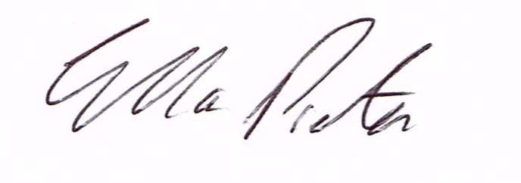
ELLA PRESTON
CLERK TO HIGHLEY PARISH COUNCIL.

AGENDA:

00. Parishioners Time (15 minutes) - Speaking at a Meeting - You do not have the right to speak at a meeting unless invited to do so by the Council. If you wish to speak then you must contact the Clerk beforehand or make yourself known to the Clerk/Chair at the start of the meeting.

Declaration of any disclosable pecuniary interest in a matter to be discussed at the meeting. Members are reminded that they are required to leave the room during the discussion and voting on matters in which they have a disclosable pecuniary interest, whether the interest is entered in the register of member’s interest maintained by the monitoring officer.

01. Election of Officers

Election of Chair
Election of Vice Chair
Election of Working Groups/Committees
To look at delegated powers for working groups/committees

02. Apologies for absence

03. To confirm the minutes of the meeting dated 2nd April 2019

04. Matters Arising
Parking Bays – Village Centre – report from meeting
Castle Inn Update
Bus Shelter Clee View- report from meeting
Annual Parish Meeting – Civil Enforcement - Parking
Mr.P.Nutting – Bridgnorth/Highley Road.

05. Correspondence
Emailed to all Councillors
Shropshire Council - BRIEFING NOTE FOR TOWN AND PARISH COUNCILS - Review of A-Boards Policy & Process – Gary Parton, Traffic Manager, Street Works Team.
SALC – Information Bulletin
SALC – GDPR Training
SALC – planning and Cil Training
SALC – Funding and Governance Training – 10th May 2019
Severn Valley Country park Bulletin
Shropshire Council – High Street Clean up
Plus any correspondence that comes in prior to meeting.

06. Planning
Planning Decision

18/02555/FUL (validated: 05/06/2018) - Address: Proposed Residential Development Land West Of 5 Carlton Rise, Highley, Shropshire - Proposal: Erection of one detached dwelling and associated works (amended plans)
Decision: Grant Permission

07. Defibulator – Update

08. Smart water – Update

09. St. Marys Churchyard – Grant for Churchyard

10. Severn Centre – Annual Grant

11. Highley Place Plan Document - Comments

12. SALC – Afflation Fees

13. Highley Companions – Grant Request for Dementia Buddies

14. Finance: Clerks Salary. HMRC – Tax and National Insurance. Severn Centre Trust – Room Hire, Npower – Street Lighting.

Plus any payments that come in prior to meeting.

