HIGHLEY PARISH COUNCIL
Clerk: Mrs E Preston
81 Woodhill Road, Highley, Bridgnorth, Shropshire, WV16 6HU
Telephone: 01746 861979
Email: prestonhighleypc@aol.com

Date: 26th March 2016
To: All Parish Council members
The Public and Press

You are summoned to attend an Ordinary meeting of Highley Parish Council which will be held on Tuesday 5th April 2016 at the SEVERN CENTRE, HIGHLEY at 7pm for the transaction of business as set out in the agenda below.
Members of the public are invited to address the Council at the start of the meeting.

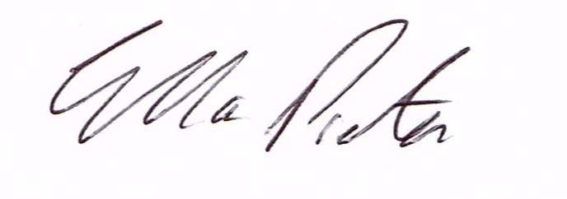

ELLA PRESTON
CLERK TO HIGHLEY PARISH COUNCIL.
26th March2016

AGENDA:

00. Parishioners Time (15 minutes)

Declaration of any disclosable pecuniary interest in a matter to be discussed at the meeting. Members are reminded that they are required to leave the room during the discussion and voting on matters in which they have a disclosable pecuniary interest, whether or not the interest is entered in the register of member’s interest maintained by the monitoring officer.

01. Apologies for absence
02. To confirm the minutes of the meeting dated 1st March 2016
03. Matters arising from minutes:-
Swimming Pool Funding – Update
Summer Pride
Plus any other matters arising that are received before meeting
04. Correspondence:
SALC Information Bulletin
Shropshire Council – Consultation three draft Supplementary Planning Document information.
Severn Centre – Grounds Maintenance Report
SALC – Voluntary Sector Newsletter.
SALC – Healthwatch Newsletter
Rural Services Network - Newsletter
Severn Centre - Briefing Note
Alan Griffiths – Bridgnorth Choir – Singing for Pleasure Workshop – 16th April
Plus any other correspondence received before meeting
05. Planning Applications – To look at any applications received.
06. Speeding along Woodhill Road (Behind Castle Inn) – Cllr. R.Honeybourne
07. Queens 90th Birthday – Councillor R.Honeybourne
08. Councillors Conduct/ Interests at meeting – Cllr R.Honeybourne
10. Highley’s Flower Displays
09. Shropshire Councillor Report.
10. Finance: Accounts outstanding: Clerks Salary. Tax and National Insurance.
Eon – Street Lighting. Severn Centre – Room Hire. SALC – Training events.
Plus any cheques that come in prior to meeting.

CORRESPONDENCE
All correspondence and plans will be available for inspection by Parish Councillors prior to the meeting by contacting the clerk or from 6.30pm on the night of the Parish Council meeting. Parish Councillors if you wish any item to be discussed at the meeting please inform the clerk.

