HIGHLEY PARISH COUNCIL
Clerk: Mrs E Preston
81 Woodhill Road, Highley, Bridgnorth, Shropshire, WV16 6HU
Telephone: 01746 861979
Email: clerk@highleyparish.couk

Date: 24th March 2019
To: All Parish Council members
The Public and Press

You are summoned to attend an Ordinary Meeting of Highley Parish Council which will be held on Tuesday 2nd April 2019 at the SEVERN CENTRE, HIGHLEY at 7pm for the transaction of business as set out in the agenda below.
Members of the public are invited to address the Council at the start of the meeting.

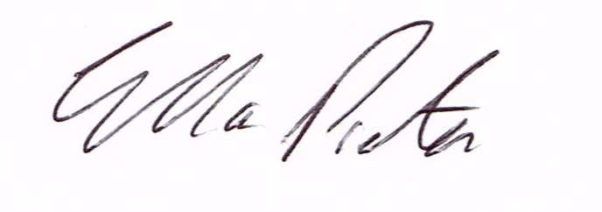
ELLA PRESTON
CLERK TO HIGHLEY PARISH COUNCIL.

AGENDA:

00. Parishioners Time (15 minutes) - Speaking at a Meeting - You do not have the right to speak at a meeting unless invited to do so by the Council. If you wish to speak then you must contact the Clerk beforehand or make yourself known to the Clerk/Chair at the start of the meeting.

Declaration of any disclosable pecuniary interest in a matter to be discussed at the meeting. Members are reminded that they are required to leave the room during the discussion and voting on matters in which they have a disclosable pecuniary interest, whether the interest is entered in the register of member’s interest maintained by the monitoring officer.

01. Apologies for absence

02. To confirm the minutes of the meeting dated 5th March 2019

03. Matters Arising
CCTV – Police and Crime Commissioner
Parking Bays – Village Centre
Report from place Plan meeting.
West Mercia Police – Speed data collections

04. Correspondence
Emailed to all Councillors
Care Choices – Information on New Website
NHS in Shropshire – survey
Shropshire Council – proposed changes for Travel assistance for SEND Nursey and Post 16 students.
Shropshire Council – Road Closure Bind Lane – 22 to the 24th April

05. Planning

Planning Decision
19/00691 – 13 Yew Tree Grove – Erection of single storey extension – Grant Permission

06. Defibulator – from last meeting

07. Smart water – from last meeting

08. Severn Valley Country Park – Park Run – Request for Donation

09. Finance: Clerks Salary. HMRC – Tax and National Insurance. Severn Centre Trust – Room Hire, SALC – training.

Plus any payments that come in prior to meeting.

