HIGHLEY PARISH COUNCIL
Clerk: Mrs E Preston
81 Woodhill Road, Highley, Bridgnorth, Shropshire, WV16 6HU
Telephone: 01746 861979
Email: prestonhighleypc@aol.com

Date: 13th October 2016.
To: Finance and Resources Committee – Cllrs. M.Brooks, N.Barker, J.Law, R.Broome,
D.Thakrar, A.Honeybourne

You are summoned to attend a meeting of The Finance and Resources Committee of Highley Parish Council which will be held on Wednesday 19th October 2016 at the SEVERN CENTRE, HIGHLEY at 12.30pm for the transaction of business as set out in the agenda below.

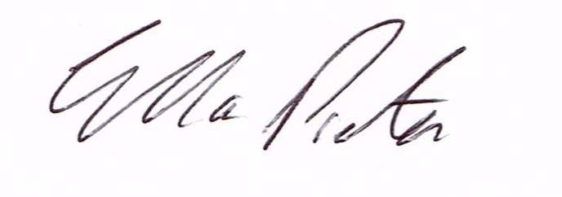

E.Preston
Clerk Highley Parish Council

AGENDA:

Declaration of any disclosable pecuniary interest in a matter to be discussed at the meeting. Members are reminded that they are required to leave the room during the discussion and voting on matters in which they have a disclosable pecuniary interest, whether or not the interest is entered in the register of member’s interest maintained by the monitoring officer.

01. Apologies for absence.
02. LEADER Application Form – To look at documents as attached.

