HIGHLEY PARISH COUNCIL
Clerk: Mrs E Preston
81 Woodhill Road, Highley, Bridgnorth, Shropshire, WV16 6HU
Telephone: 01746 861979
Email: prestonhighleypc@aol.com

Date: 21st December 2015
To: All Parish Council members
The Public and Press

You are summoned to attend an Ordinary meeting of Highley Parish Council which will be held on Tuesday 5th January 2016 at the SEVERN CENTRE, HIGHLEY at 7pm for the transaction of business as set out in the agenda below.
Members of the public are invited to address the Council at the start of the meeting.

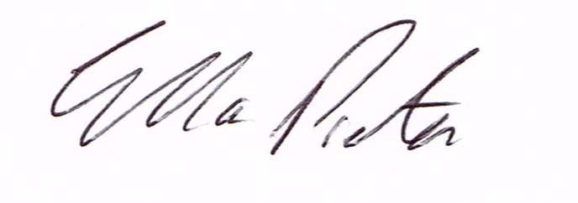

ELLA PRESTON
CLERK TO HIGHLEY PARISH COUNCIL.
21st December 2015

AGENDA:

00. Parishioners Time (15 minutes)

Declaration of any disclosable pecuniary interest in a matter to be discussed at the meeting. Members are reminded that they are required to leave the room during the discussion and voting on matters in which they have a disclosable pecuniary interest, whether or not the interest is entered in the register of member’s interest maintained by the monitoring officer.

01. Apologies for absence
02. To confirm the minutes of the meeting dated 1st December 2015
03. Matters arising from minutes:-
Swimming Pool Funding – Update
Street Naming – Name Chosen for the Cedars – Staley Grove.
Alice Dilly – Upgrading of warning signs for crossing at Ashleigh Gardens
Plus any other matters arising that are received before meeting
04. Correspondence:
SALC – Invitation to Road Safety Event at Shirehall March 2016.
Rural Service Network Bulletin
SALC – Invitation to Shropshire Community Assets and Services – Inspiration Event
Shropshire Council – The Big Conversation Town and Parish Council Workshop 18/1/16
West Power Distribution – Invitation to Annual Stakeholders Workshop
Vicky Turner – Local Joint Committee Agenda for meeting 12/1/16.
Shropshire Council – Health and Wellbeing Newsletter
Plus any other correspondence received before meeting
05. Planning Applications
15/0528/REM – Approval of Reserved Matters (access, appearance, landscaping, layout and scale) pursuant to permission 12/02334/OUT for residential development to include discharge of conditions no 1, 2, 4 and y – Land at Rhea Hall Estate Highley.
05. Severn Centre Friends and User Group – Verbal Report
06. St. Marys Churchyard Maintenance Contract. – From last meeting.
07. Scout/Brownie Hut – Grant Request. – From last meeting
08. Bus Shelter Replacements - Cllr.Brooks – from last meeting
09. Highley Parish Council Web Site. – Report from meeting with Web Orchard (website provider)
10. Shropshire Councillor Report.
11. Finance: Accounts outstanding: Clerks Salary. Tax and National Insurance.
K.Russon – Maintenance Contractor. Severn Centre – Room Hire. Eon – Street Lighting.
Plus any cheques that come in prior to meeting.

CORRESPONDENCE
All correspondence and plans will be available for inspection by Parish Councillors prior to the meeting by contacting the clerk or from 6.30pm on the night of the Parish Council meeting. Parish Councillors if you wish any item to be discussed at the meeting please inform the clerk.

