HIGHLEY PARISH COUNCIL
Clerk: Mrs E Preston
81 Woodhill Road, Highley, Bridgnorth, Shropshire, WV16 6HU
Telephone: 01746 861979
Email: prestonhighleypc@aol.com

Date: 1st January 2017.
To: All Parish Council members
The Public and Press

You are summoned to attend an Ordinary meeting of Highley Parish Council which will be held on Tuesday 10th January 2017 at the SEVERN CENTRE, HIGHLEY at 7.00pm for the transaction of business as set out in the agenda below.
Members of the public are invited to address the Council at the start of the meeting.

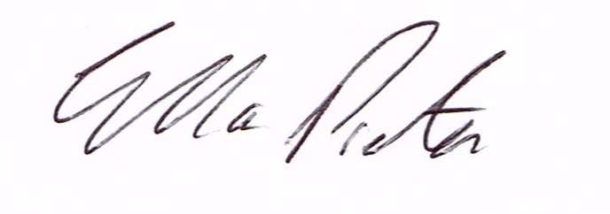
ELLA PRESTON
CLERK TO HIGHLEY PARISH COUNCIL.

AGENDA:

00. Parishioners Time (15 minutes)

Declaration of any disclosable pecuniary interest in a matter to be discussed at the meeting. Members are reminded that they are required to leave the room during the discussion and voting on matters in which they have a disclosable pecuniary interest, whether or not the interest is entered in the register of member’s interest maintained by the monitoring officer.

01. Apologies for absence.
02. To confirm the minutes of the meeting dated 6th December 2016.
03. Matters arising from minutes:-
3.1. Highley Swimming Pool – Update
3.2. Churchyard – Update
3.3. Setts Village Centre – email Graham Downes
04. Correspondence:
SALC – Shropshire Bus Strategy – Consultation
NHS – Future Fit Digest
NALC – Council Tax principles – no changes to referendum principles.
Shropshire Council – Shropshire Local Plan Review Briefing.
SALC – Information Bulleting

05. To look at any planning applications received.
6/05578/REM – Reserved matters pursuant to Outline permission reference 14/05400/OUT – dated 9/7/15 for the provision of 35 residential units comprising 10 shared ownership its ad 20 open market dwellings to include appearance, landscaping, layout and scale – Land adj. The Cedars, Bridgnorth Road, Highley, Bridgnorth, Shropshire.
06. Parish Council Precept requirements – 2017/2018 – Recommendations from the Revenue and Resources Committee -
07. Report from meeting held with Severn Centre Trust/Halo Leisure/Shropshire Council. –
Verbal report – Cllr.N.Barker.
08. Shropshire Councillors Report.
09. Finance: Accounts outstanding: Clerks Salary. Tax and National Insurance.
Plus any cheques that come in prior to meeting.

CORRESPONDENCE
All correspondence and plans will be available for inspection by Parish Councillors prior to the meeting by contacting the clerk or from 6.30pm on the night of the Parish Council meeting. Parish Councillors if you wish any item to be discussed at the meeting please inform the clerk.

