HIGHLEY PARISH COUNCIL
Clerk: Mrs E Preston
81 Woodhill Road, Highley, Bridgnorth, Shropshire, WV16 6HU
Telephone: 01746 861979
Email: clerk@highleyparish.couk

Date: 24th June 2019
To: All Parish Council members
The Public and Press

You are summoned to attend an ordinary Meeting of Highley Parish Council which will be held on Tuesday 2nd July 2019 at the SEVERN CENTRE, HIGHLEY at 7pm for the transaction of business as set out in the agenda below.
Members of the public are invited to address the Council at the start of the meeting.

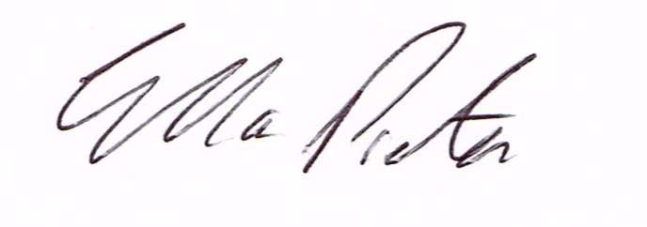
ELLA PRESTON
CLERK TO HIGHLEY PARISH COUNCIL.

AGENDA:

00. Parishioners Time (15 minutes) - Speaking at a Meeting - You do not have the right to speak at a meeting unless invited to do so by the Council. If you wish to speak then you must contact the Clerk beforehand or make yourself known to the Clerk/Chair at the start of the meeting.

Declaration of any disclosable pecuniary interest in a matter to be discussed at the meeting. Members are reminded that they are required to leave the room during the discussion and voting on matters in which they have a disclosable pecuniary interest, whether the interest is entered in the register of member’s interest maintained by the monitoring officer.

01. Apologies for absence

02. To confirm the minutes of the meeting dated 4th June 2019

03. Matters Arising
Parking Bays – Village Centre/Extended Yellow Lines Coronation Street
Church Street – Parking Issues – Awaiting reply from Shropshire Council
Castle Inn – Awaiting updates
Remembrance Lamp Post Poppies – 100 ordered
Bridgnorth/Highley Road Cllr.Nutting – Report from meeting – Cllr.Court
04. Correspondence
Emailed to all Councillors
SALC information Bulletin
Shropshire Council – Highways and Transport Briefing note
Rural Services Network Bulletin

05. Planning

19/02552/TPO – Land North of Kinlet View – Fell 1 Oak Tree protected by Shropshire Council.
Tree preservation Order – South of Vicarage Lane and west of St. Peters View
Tree preservation order – Land at Abdon Close, Wyre Close and Staley Grove

06.Telephone Box Ashleigh Gardens – to agree expenditure electrical supply to box
07. Severn Centre – Report from monthly meeting Cllr.Court

08. Raising profile of Parish Council – Cllr.Court – To look at ways to raise the profile of the Parish
Council.

09.Shropshire Councillors Report.

10. Finance: Clerks Salary. HMRC – Tax and National Insurance. Severn Centre Trust – Room Hire, Eon – Street Lighting, Shorthouse’s – Skip Hire. Information Commissioner – Data Protection Renewal Fees. S.J.Maintenance – Village Maintenance issues. B.White – Bedding Plants
Plus any payments that come in prior to meeting.

