HIGHLEY PARISH COUNCIL
Clerk: Mrs E Preston
81 Woodhill Road, Highley, Bridgnorth, Shropshire, WV16 6HU
Telephone: 01746 861979
Email: clerk@highleyparish.couk

Date: 6th July 2020
To: All Parish Council members
The Public and Press

You are summoned to attend an ordinary Meeting of Highley Parish Council which will be held via video link (Zoom) Tuesday 14th July 2020 at 7pm for the transaction of business as set out in the agenda below.
Members of the public are invited to address the Council at the start of the meeting.

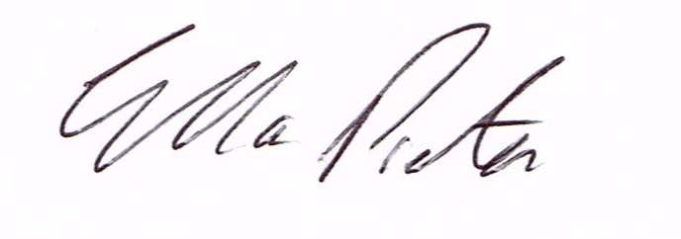
ELLA PRESTON
CLERK TO HIGHLEY PARISH COUNCIL.

AGENDA:

00. Parishioners Time (15 minutes) - Speaking at a Meeting - You do not have the right to speak at a meeting unless invited to do so by the Council. If you wish to speak then you must contact the Clerk beforehand so that a link to the meeting can be emailed to you. .

Declaration of any disclosable pecuniary interest in a matter to be discussed at the meeting. Members are reminded that they are required to leave the room during the discussion and voting on matters in which they have a disclosable pecuniary interest, whether the interest is entered in the register of member’s interest maintained by the monitoring officer.

01 Apologies for absence and reasons for absence

02 To confirm the minutes of the meeting dated 9th June 2020

03 Matters Arising
CCTV – Awaiting start date from Technical Services.
Container- Delivered
Village Flowers – Update from Clerk

04. Correspondence (All correspondence emailed to Councillors)

05. Planning
20/0243/Full- Land Rear of Bache Arms – Erection of four Terraced Houses and formation of parking area and on-site driveways – please could councillor’s access Shropshire Councils website to view planning application prior to meeting so they have all relevant information.

06. Land East of Bridgnorth Road – Land designated as public open space - Letter emailed to all Councillors.

07. Bus Stop Village Centre – To consider future of Bus Stop due to recurring damage

08. Local Plan - email sent to all Councillors.

09. Youth Project – Information emailed to all Councillors by Cllr.Vinall

10. To pass a Resolution That under the Public Bodies (Admission to Meetings) Act 1990, the public and representatives of the press and broadcast media be excluded from the meeting during the consideration of the following items of business as publicity would be prejudiced to the public interest because of the confidential nature of the business to be transacted.
11. Severn Centre – Paperwork emailed to all Councillors

12. Shropshire Councillors Report. Report emailed to all Councillors

13. Finance: Clerks Salary - HMRC – Tax and National Insurance. , S.J.Maintenance – Village Maintenance issues. Bill White – Village Hanging Baskets. Plus, any other invoices received prior to meeting

