HIGHLEY PARISH COUNCIL
Clerk: Mrs E Preston
81 Woodhill Road, Highley, Bridgnorth, Shropshire, WV16 6HU
Telephone: 01746 861979
Email: clerk@highleyparish.couk

Date: 26th May 2019
To: All Parish Council members
The Public and Press

You are summoned to attend an ordinary Meeting of Highley Parish Council which will be held on Tuesday 4th June 2019 at the SEVERN CENTRE, HIGHLEY at 7pm for the transaction of business as set out in the agenda below.
Members of the public are invited to address the Council at the start of the meeting.

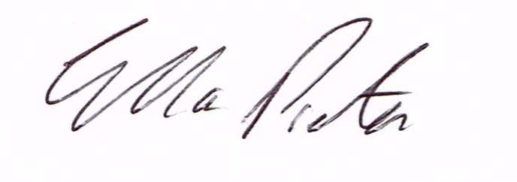
ELLA PRESTON
CLERK TO HIGHLEY PARISH COUNCIL.

AGENDA:

00. Parishioners Time (15 minutes) - Speaking at a Meeting - You do not have the right to speak at a meeting unless invited to do so by the Council. If you wish to speak then you must contact the Clerk beforehand or make yourself known to the Clerk/Chair at the start of the meeting.

Declaration of any disclosable pecuniary interest in a matter to be discussed at the meeting. Members are reminded that they are required to leave the room during the discussion and voting on matters in which they have a disclosable pecuniary interest, whether the interest is entered in the register of member’s interest maintained by the monitoring officer.

01. Election of Councillor for Vacant Position

02. Apologies for absence

03. To confirm the minutes of the meeting dated 7th May 2019

04. Matters Arising
Parking Bays – Village Centre/Extended Yellow Lines Coronation Street –
Defibrillator – Awaiting reply from British Telecom
Church Street – Parking Issues – Awaiting reply from Shropshire Council
CCTV – Awaiting Start Date from Technical Services
Castle Inn – Awaiting updates
Bridgnorth/Highley Road Cllr.Nutting – Report from meeting – Cllr.Court
Severn Centre – Report from meeting. Will be emailed to all Councillors prior to meeting.
Allotments Update - Clerk

05. Correspondence
Emailed to all Councillors
There but Not There D Day Commemorations – Bulletin
SALC – D-day 75 information
SALC – Care Closer to Home Newsletter
SALC – Great British High Street Awards
Housing Group Plus – Merger update
SALC – Joint Funding workshop with VCSA – Friday 2nd June 9am – 1pm
CCG Board – Letter regarding an update on proposals to become one organisation.
Rural Services Newsletter
Severn Centre Monthly Report
Rural Crime Prevention Evenings 25th/27th June

06. Planning

Planning Decision
Reference: 18/04645/FUL (validated: 30/10/2018)
Address: Proposed Holiday Let Log Cabin South of New England Lane, Highley, Shropshire
Proposal: Erection of a log cabin holiday let and parking space
Decision: Refuse

07. Parish Council Accounts – Internal Auditors Report/Statement of Assurance

08. Highley Swimming Pool – Concerns about proposed opening times as per Severn Centre published timetable – Cllr. Broome

09. Help us Remember D Day Celebrations – Original email sent to Councillors - Cllr. Brooks.
10. Police and Crime Commissioner – Parish and Town Council Survey
11. Resolution that under the Public Bodies (Admission to Meetings) Act 1960, the public and representatives of the press be excluded from the meeting during the consideration of the following item of business as publicity would be prejudicial to the public interest because of the confidential nature of the business to be transacted.
12. Star Housing – Cllr. G.Court on behalf of a Parishioner.

13.Shropshire Councillors Report.

14. Finance: Clerks Salary. HMRC – Tax and National Insurance. Severn Centre Trust – Room Hire, Herbert & Son – Hedge cutting – 2019. Web Orchard – Setting up emails Cllr. R.Honeybourne and Cllr. A.Honeybourne.

Plus any payments that come in prior to meeting.

