HIGHLEY PARISH COUNCIL
Clerk: Mrs E Preston
81 Woodhill Road, Highley, Bridgnorth, Shropshire, WV16 6HU
Telephone: 01746 861979
Email: clerk@highleyparish.couk

Date: 23rd September 2019
To: All Parish Council members
The Public and Press

You are summoned to attend an ordinary Meeting of Highley Parish Council which will be held on Tuesday 1st October at the SEVERN CENTRE, HIGHLEY at 7pm for the transaction of business as set out in the agenda below.
Members of the public are invited to address the Council at the start of the meeting.

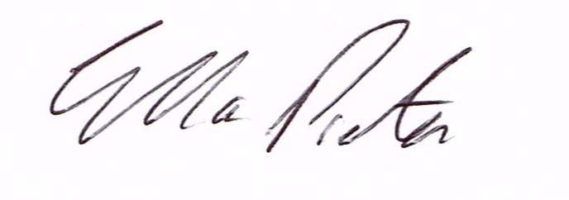
ELLA PRESTON
CLERK TO HIGHLEY PARISH COUNCIL.

AGENDA:

00. Parishioners Time (15 minutes) - Speaking at a Meeting - You do not have the right to speak at a meeting unless invited to do so by the Council. If you wish to speak then you must contact the Clerk beforehand or make yourself known to the Clerk/Chair at the start of the meeting.

Declaration of any disclosable pecuniary interest in a matter to be discussed at the meeting. Members are reminded that they are required to leave the room during the discussion and voting on matters in which they have a disclosable pecuniary interest, whether the interest is entered in the register of member’s interest maintained by the monitoring officer.

01. Apologies for absence.

02. To confirm the minutes of the meeting dated 3rd September 2019

03. Matters Arising
Allotments - Ready to hand to tenants end of September
Church Street - – Awaiting a reply from Shropshire Council regarding parking problems.
Defibrillator – Awaiting response from BT regarding the decommissioning of the Phone Box.
Castle Inn Update – Shropshire Council - Awaiting update from Shropshire Council.
CCTV - Another meeting to be arranged with EON and -- Tech Services.
Parking Bays Village Centre/Lines Coronation Street - Awaiting response from Shropshire Council.

04. Correspondence (All correspondence emailed to Councillors)

Shropshire RCC - Village Halls Conference - Saturday 19th October 2019
SALC - September Bulletin
Rural Services Network - September Bulletin
West Midlands Trains - Customer and Communities Improvement Fund
Cleobury Country Centre - Level 2 Award in Food Safety.
Shropshire Council - Planning Appeal - Land rear of Beech Croft, Vicarage lane, Highley.
Shropshire Council - Youth Support Consultation Survey
Shropshire Rural Communities Charities - Grant panel members
Shropshire Council - Country Wide Potholing Scheme
Shropshire Council - Suicide ZCard
Shropshire Council - Street Trading Policy
Severn Valley Country Park - 50th Anniversary of Alveley Colliery Closure.
SALC - Traffic Calming Briefing.
Plus any other correspondence received prior to meeting

05. Planning

Planning Decision

Reference : 19/02791/FUL - Proposed Residential Development Land East of Bridgnorth Road, Highley - Erection of 20 (affordable) dwellings with estate road, using existing vehicular access.
Planning Decision - Refuse

Reference: 19/03585/FUL (validated: 14/08/2019)
Address: 55 Redstone Drive, Highley, Shropshire, WV16 6EQ
Proposal: Erection of single storey front extension
Decision: Grant Permission

06. Severn Centre – Report from monthly meeting Cllr.Court
b. Agenda Items for Board Meeting

08. AGAR Report for Auditors - To approve report

09. Churchyard - From last meeting - Cllr.J.Law

10. Christmas Lights - Nominations for persons to switch on Christmas Lights

11.Shropshire Councillors Report. - Report Attached

12. Finance: Clerks Salary. HMRC – Tax and National Insurance. Severn Centre Trust – Room Hire, Eon – Street Lighting, S.J.Maintenance – Village Maintenance issues. PKF Littlejohn - Audit Fees Plus any payments that come in prior to meeting.

