HIGHLEY PARISH COUNCIL
Clerk: Mrs E Preston
81 Woodhill Road, Highley, Bridgnorth, Shropshire, WV16 6HU
Telephone: 01746 861979
Email: clerk@highleyparish.couk

Date: 4th October 2020
To: All Parish Council members
The Public and Press

You are summoned to attend an ordinary Meeting of Highley Parish Council which will be held via video link (Zoom) Tuesday 13th October 2020 at 7pm for the transaction of business as set out in the agenda below.
Members of the public are invited to address the Council at the start of the meeting.

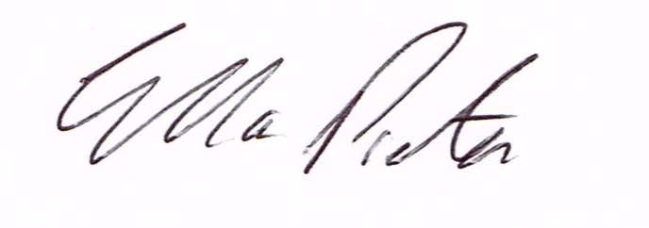
ELLA PRESTON
CLERK TO HIGHLEY PARISH COUNCIL.

AGENDA:

00. Parishioners Time (15 minutes) - Speaking at a Meeting - You do not have the right to speak at a meeting unless invited to do so by the Council. If you wish to speak /attend, then you must contact the Clerk beforehand so that a link to the meeting can be emailed to you. .

Declaration of any disclosable pecuniary interest in a matter to be discussed at the meeting. Members are reminded that they are required to leave the room during the discussion and voting on matters in which they have a disclosable pecuniary interest, whether the interest is entered in the register of member’s interest maintained by the monitoring officer.

01 Apologies for absence and reasons for absence

02 To confirm the minutes of the meeting dated

03. Matters Arising
CCTV – Awaiting start date from Technical Services.
Youth Project – Update from Cllr.Vinall.
Bus Shelter Village Centre – Update
SALC – Website Accessibility – update
Severn Centre – Update from last meeting
Castle Inn - Update

06.Correspondence (All correspondence emailed to Councillors – if you wish anything discussed please contact the Clerk).
Shropshire Council – Borle Mill Junction to the Junction with the B4363
Highley Rector – Remembrance Day
SALC – Planning White Paper – Consultation

07. Planning
Reference: 20/03697/OUT (validated: 15/09/2020)
Address: Land West Of, 13 Beech Street, Woodhill, Highley, Shropshire
Proposal: Outline application (all matters reserved) for the erection of one pair of semi-detached dwellings

Reference: 20/03692/FUL (validated: 15/09/2020)
Address: 15 Wyre Close, Highley, WV16 6DX
Proposal: Erection of single storey side extension and garage conversion

Planning Decision
Reference: 20/02509/FUL (validated: 31/07/2020)
Address: 32 Redstone Drive, Highley, Bridgnorth, Shropshire, WV16 6EQ
Proposal: Erection of first floor extension
Decision: Grant Permission

Reference: 20/03038/REM (validated: 05/08/2020)
Address: Proposed Dwelling At The Site Of 2 Cherry Orchard, Severn Side, Highley, Shropshire
Proposal: Approval of reserved matters (access, appearance, landscaping, layout and scale) in pursuance of outline planning permission No. 18/03032/OUT for the erection of 1No dwelling
Decision: Grant Permission

08. Christmas Lights – to agree expenditure on new lights

09. Severn Centre – Management Fee

10.Cemetry Land – To look at setting up working group

11. Shropshire Councillors Report. Report attached.

12. Finance: Clerks Salary - HMRC – Tax and National Insurance. , S.J.Maintenance – Village Maintenance issues. Viking Direct – Stationery. Severn C entre – Room Hire. .00 . Plus, any other invoices received prior to meeting

