HIGHLEY PARISH COUNCIL
Clerk: Mrs E Preston
81 Woodhill Road, Highley, Bridgnorth, Shropshire, WV16 6HU
Telephone: 01746 861979
Email: clerk@highleyparish.couk

Date: 29th August 2020
To: All Parish Council members
The Public and Press

You are summoned to attend an ordinary Meeting of Highley Parish Council which will be held via video link (Zoom) Tuesday 8th September 2020 at 7pm for the transaction of business as set out in the agenda below.
Members of the public are invited to address the Council at the start of the meeting.

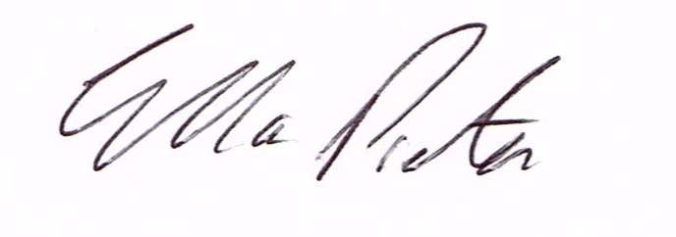
ELLA PRESTON
CLERK TO HIGHLEY PARISH COUNCIL.

AGENDA:

00. Parishioners Time (15 minutes) - Speaking at a Meeting - You do not have the right to speak at a meeting unless invited to do so by the Council. If you wish to speak /attend, then you must contact the Clerk beforehand so that a link to the meeting can be emailed to you. .

Declaration of any disclosable pecuniary interest in a matter to be discussed at the meeting. Members are reminded that they are required to leave the room during the discussion and voting on matters in which they have a disclosable pecuniary interest, whether the interest is entered in the register of member’s interest maintained by the monitoring officer.

01 Apologies for absence and reasons for absence

02. Mr. Scott Rolfe – Halo - Severn Centre

03. C0-option of Parish Councillor – details sent to all Councillors

04 To confirm the minutes of the meeting dated 14th July 2020, 30th July 2020, and 20th August 2020.

05 Matters Arising
CCTV – Awaiting start date from Technical Services.
Youth Project – Update from Cllr.Vinall.
Bus Shelter Village Centre – Information sent to all Councillors.
Land East off Bridgnorth Road – Public Open Space land/Crossing point – update.
Remembrance Concert – Update
Christmas Light Switch on - Update

06.Correspondence (All correspondence emailed to Councillors)

07. Planning

08. Shropshire Councillors Report. Report to follow.

09. Finance: Clerks Salary - HMRC – Tax and National Insurance. , S.J.Maintenance – Village Maintenance issues. D. Green – planting Hagg Corner . Plus, any other invoices received prior to meeting

