HIGHLEY PARISH COUNCIL
Clerk: Mrs E Preston
81 Woodhill Road, Highley, Bridgnorth, Shropshire, WV16 6HU
Telephone: 01746 861979
Email: prestonhighleypc@aol.com
www.highleyparish.com

Date: 19th December 2016
To: All Finance and Resources committee members (Cllr. M.Brooks, Cllr.R.Broome, Cllr.J.Law, Cllr. D.Thakrar, Cllr. A.Honeybourne, Cllr N.Barker, Cllr.J.Marshall
The Public and Press

You are summoned to attend a meeting of the Finance and Resources Committee which will be held on WEDNESDAY 4TH JANUARY 2017 at 10.30m at the SEVERN CENTRE, HIGHLEYt for the transaction of business as set out in the agenda below.

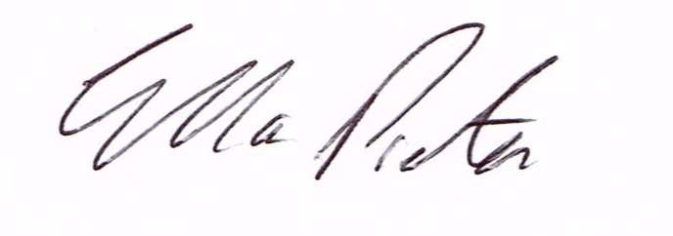
ELLA PRESTON
CLERK TO HIGHLEY PARISH COUNCIL.

AGENDA:

Declaration of any disclosable pecuniary interest in a matter to be discussed at the meeting. Members are reminded that they are required to leave the room during the voting on matters in which they have a disclosable pecuniary interest, whether or not the interest is entered in the register of member’s interest maintained by the monitoring officer.

01. Apologies for absence
02. To confirm minutes of meeting held on 29th November 2016
03. Resolution that under the Public Bodies (Admission to Meetings) Act 1960, the public and representatives of the press be excluded from the meeting during the consideration of the following item of business as publicity would be prejudicial to the public interest because of the confidential nature of the business to be transacted.
04.To finalise Precept for 2017/18 for recommendation to the Parish Council at the meeting on 10th January 2017

