HIGHLEY PARISH COUNCIL
Clerk: Mrs E Preston
81 Woodhill Road, Highley, Bridgnorth, Shropshire, WV16 6HU

To: Highley Parish Councillors
The Public and Press

You are summoned to attend a Meeting of Highley Parish Council which will be held on Tuesday 5th April 2022 at 7pm at the Severn Centre, Highley. for the transaction of business as set out in the agenda below.

Members of the public are invited to address the Council at the start of the meeting .Due to Covid Restrictions please contact the Clerk prior to the meeting to book a space.

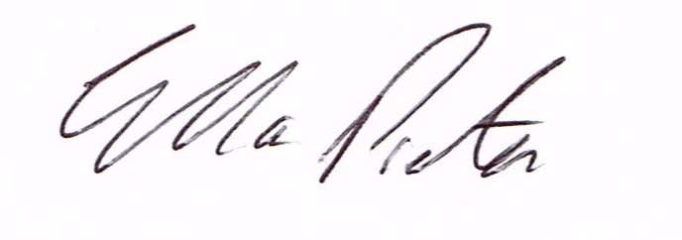
ELLA PRESTON
CLERK TO HIGHLEY PARISH COUNCIL.

AGENDA:

00. Parishioners Time (15 minutes) - Speaking at a Meeting - You do not have the right to speak at a meeting unless invited to do so by the Council. If you wish to speak /attend, then you must contact the Clerk beforehand so that a link to the meeting can be emailed to you.

Declaration of any disclosable pecuniary interest in a matter to be discussed at the meeting. Members are reminded that they are required to leave the room during the discussion and voting on matters in which they have a disclosable pecuniary interest, whether or not the interest is entered in the register of member’s interest maintained by the monitoring officer.

01 Apologies for absence and reasons for absence

02 To confirm the minutes of the meetings dated 2021

03. Police – PC Wayne Strangwood

04. Election of Parish Councillors

05. Shropshire Councillor – D.Tremellen

06. Matters Arising
Youth Services – Highley Reach Report – Cllr. P.Vinall.
Report from Communications Working Group – Notes attached.
Report from Meeting with Shropshire Council Highways – Notes attached.
Report from Meeting with Highley School – Notes Attached Report from Environmental Working Group meeting.
Report from meeting with Tom Bretall re – Highley Medical Centre.

07. Correspondence
Road Closure: B4555 Eardington to Hay Bridge - Start Date: 11th May 2022 - End Date: 14th June 2022
2Keep Britain Tidy – Great British Spring Clean
SALC – NALC Newsletter
SALC – Monthly Bulletin
Shropshire Council – Pay and Display Consultation..
SALC - Increased levels of pharmacy appointments to improve GP access 18.03.22

07. Planning
Reference: 22/01037/FUL (validated: 22/03/2022) - Address: 14 Riverside Bungalows, Severn side, Highley, Bridgnorth, Shropshire, WV16 6NU. Proposal: Erection of single storey side extension
Applicant: Nancy WhitehouseReference:

22/00848/FUL (validated: 07/03/2022) - Address: Whitehouse Farm Barn, Netherton Lane, Highley, Shropshire, WV16 6NJ. Proposal: Application under Section 73A of the Town and Country Planning Act 1990 for the erection of a dwelling with all associated works
Applicant: Mr S Davies
Planning Decisions
Reference: 22/00446/FUL (validated: 02/02/2022) - Address: 39 Redstone Drive, Highley, Shropshire, WV16 6EQ. Proposal: Erection of first floor extension over existing garage
Decision: Grant PermissionReference:

21/04561/FUL (validated: 21/09/2021)
Address: Proposed Residential Development Land North Of Bache Arms Off, Coronation Street, Highley, Shropshire
Proposal: Erection of 2no detached dwellings
Decision: Refuse

07.Revenue and Resources Meeting – Report from meeting.

08. Finance: H.Cordey – Salary. M.E.Preston Salary. HMRC Tax & NI . OGL – Email System
Viking Stationery. Plus any cheques that come in prior to the meeting.

